  
    - 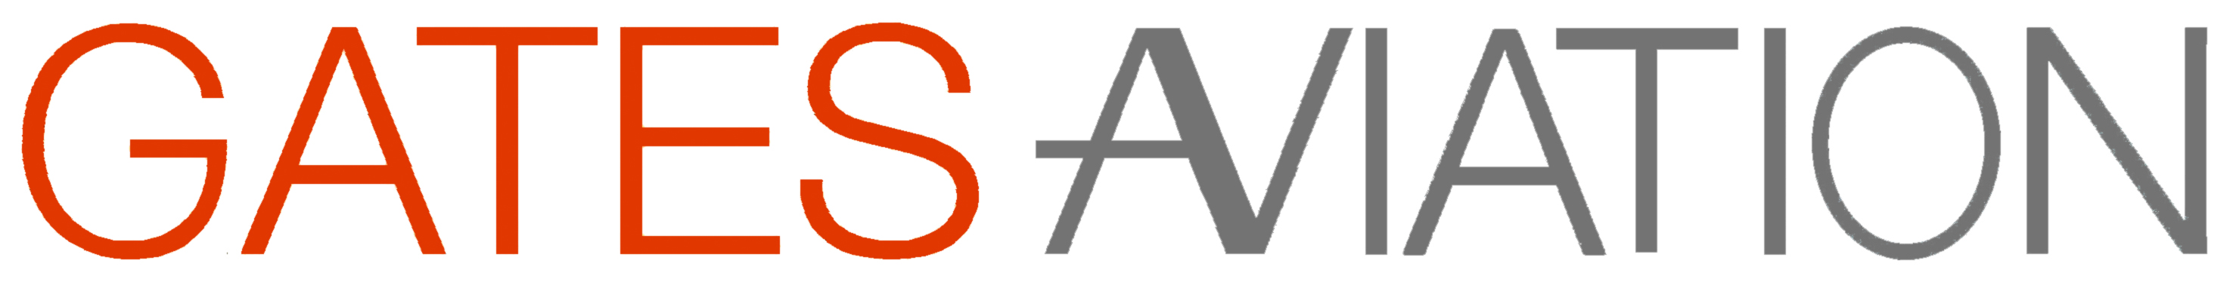
  10 Years old!
  Gates Aviation is celebrating 10 years of successful business in aviation safety, security, emergency response and legal services. What a brilliant 10 years it has been! We’d like to thank all our clients for choosing and recommending us.
  “We are delighted to celebrate the 10th anniversary of Gates Aviation’s business, dedicated to making aviation safer and better prepared.” – Sean Gates, CEO.
  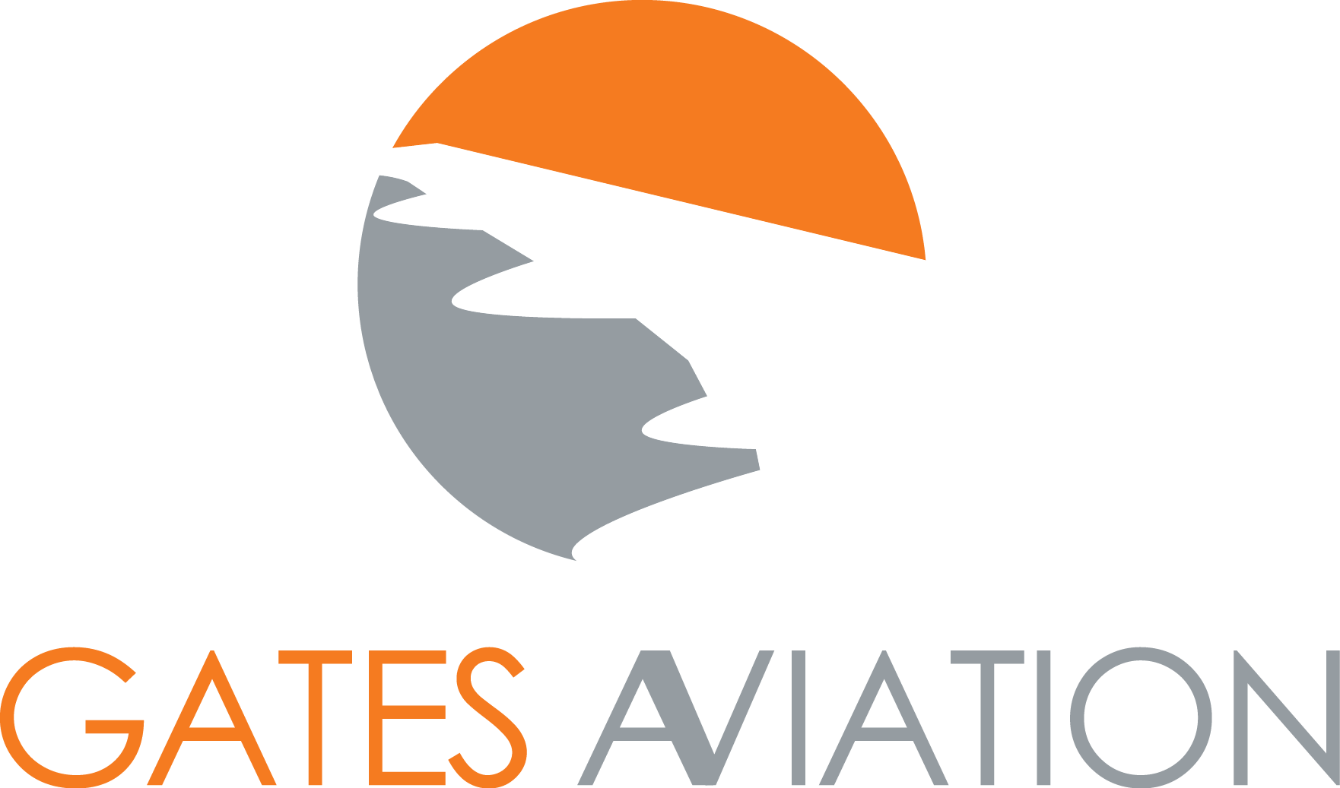
  Safety
  Security
  Emergency Response
  Legal Services
  Training
  GAtes Aviation
  68 King William Street
  London
  EC4N 7DZ
  www.gatesaviation.com
  Tel: 020 7469 6437

